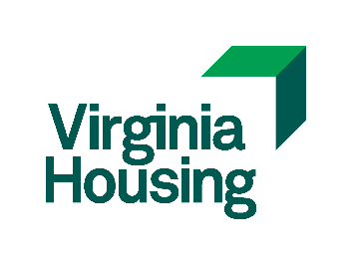

Virginia Housing LIHTC Change Request Form
Please submit document, via email, to taxcreditapps@virginiahousing.com *Please submit this document in Word format.

Property Information (Required)

Development Name:
Street:
City:
Requester Information (Required)

Name:
Email:
Date:
VH Information (Required)

Request Date:
Request Number:
Regulation Year:

Waiver Request Information (Required)

Define Requirement *Please define the requirement requesting to be waived/changed as well as the regulation year and type of construction.

Request Explanation *Please give a brief explanation of why this waiver should be considered.

*Please attach any supporting documentation and submit to VH. Submittal of this form to VH does not guarantee exemption from requirements. Requests will be approved, approved with conditions, or rejected in writing by the VH TC Allocation Department.

